**Letter of Intent to Purchase Real Estate**

July 24, 2021

Michael A Clevenger, President

Pegasus Development

3963 Garden Hwy

Sacramento CA  95834

# Re: 37 Lots in Lathrop on Scrub Oak and Wild Oak

Dear Michael,

This Letter of Intent outlines the basic terms under which Coyne Development LLC (or assignee) (“Purchaser”) intends to acquire the above-referenced real property from Pegasus Development (“Seller”) and to commence negotiations on a mutually acceptable agreement of purchase and sale (“Agreement”), which will include the following terms and conditions:

1. Property

Approximately 7.5 acres of unimproved property at the referenced location.

1. Purchase Price

The total purchase price will be $97,000 per lot, or $3,589,000 ("Purchase Price"), payable in cash at Close of Escrow.

1. Financing Contingency

There will be no financing contingency. The Purchase Price shall consist of all cash at closing.

1. Agreement

Within ten (10) business days of execution of this Letter of Intent, Purchaser will deliver to Seller a Purchase and Sale Agreement incorporating the terms and conditions set forth herein.

1. Deposits

Within five (5) business days following the execution and delivery of the Agreement by both parties to Ticor Title and Escrow (“Escrow Agent”), Purchaser will make a deposit with Escrow Agent in the amount of $50,000 (“Deposit”). The Deposit will be placed in an interest bearing escrow account with all interest accruing to the benefit of

Purchaser. The Deposit, and all interest thereon, shall be refundable to Purchaser if Purchaser decides not to proceed with the transaction upon completion of the Due Diligence Period set forth below. Upon expiration of the Due Diligence period and upon Seller’s receipt of Purchaser’s acceptance as to the conditions of the property, the Deposit shall become non-refundable to Purchaser, except for a failure to Close due to Seller’s default.

1. Due Diligence

The Agreement will require Seller to provide Purchaser with copies of certain due diligence items, to the extent that these items are in Seller’s possession or control, including the following:

* The property tax bills for the last two (2) years and value renditions;
* All Leases, License Agreements, Operating Agreements or Reciprocal Easement Agreements for the Property;
* All environmental, biological, and archaeological reports concerning the Property;
* Specific Plan, EIR and Tentative Tract Map indicating approvals and conditions of approvals;
* All plans, permits, maps, licenses, and conditions of approval;
* Current ALTA boundary survey
* Covenants, conditions and restrictions affecting the Property;
* Information regarding available utilities and locations;
* All soils, geotechnical, and engineering reports/studies on the Property;
* Title commitment dated within ten (10) days of the date of the Agreement and legible copies of all underlying documents and plotted easements;
* All architectural renderings and site plans;
* Any topographical survey or other land survey;
* Any other materials to be specified in the Agreement.

Upon mutual execution of a Purchase and Sale Agreement, Purchaser’s due diligence period (“Due Diligence Period”) will commence and will terminate one hundred twenty (120) days thereafter. During the Due Diligence Period, Seller will provide Purchaser and Purchaser’s consultants with access to the Property. Subject to the terms of the Agreement, Purchaser may make inquiries concerning the Property of third parties, including lenders, contractors, and governmental officials and representatives. Subject to the terms of the Agreement, Purchaser’s investigation of the Property may include, but not be limited to, geotechnical investigations, a Phase I environmental report, and a Phase II Investigation if recommended by the Phase I report. Purchaser shall supply proof of insurance in the amount of $1,000,000, naming Seller as additionally insured.

1. Closing

Consummation of the proposed transaction (“Closing”) will take place on or before the date which is thirty (30) calendar days after the completion of Seller’s completion of the infill of the retention basin and Buyer’s receipt of approval to construct the project from the City of Lathrop Building and Planning Departments.

1. Representations and Warranties

The Agreement will include typical and reasonable representations and warranties, including, without limitation, those with respect to the organization, authority and good standing of the parties, status of liens and outstanding litigation against Seller and the Property, and environmental condition of the Property.

1. Title; Costs and Expenses

Purchaser’s acquisition of the Property shall be subject to Purchaser’s review and approval of the condition of title to the Property including, without limitation, the review of a current ALTA survey to be obtained by Purchaser. Title will be conveyed to Purchaser subject only to those title exceptions approved by Purchaser pursuant to the terms of the Agreement. The cost to update or create a new survey shall be paid by Purchaser. Seller will pay for the cost of a CLTA policy of title insurance, in the amount of the Purchase Price and issued by Ticor Title Company, the cost of a mechanic’s lien endorsement, and any other endorsement required to remove a disapproved exception which Seller has elected to remove. Purchaser shall pay for the additional cost related to ALTA coverage and any other endorsements requested by Purchaser. Seller shall pay for all documentary transfer taxes and 50% of all escrow charges. Any other costs shall be allocated as is customary in the county where the Property is located.

1. Brokerage Commission

All brokerage commissions to be paid by Buyer per separate agreement(s).

1. Confidentiality

Purchaser will maintain the confidentiality of the terms of the transaction and the contents of this Letter of Intent and transaction documents.

`12. Removal from Market

Upon execution of a Purchase and Sale Agreement, as defined above, Seller agrees to remove the property from the market and not solicit or accept offers to purchase any portion of the Property.

1. Seller’s Obligations of Costs

The Purchase Contract shall specifically exclude Seller from responsibility to pay for work or fees incurred by Purchaser during the period of the Agreement.

1. Seller’s Counsel

Please complete the name, address, phone number and facsimile number of Seller’s legal counsel for this transaction, or if no counsel is to be used, please indicate the primary contact for questions related to this transaction:

Phone

Facsimile: E-Mail:

The transaction described in this Letter of Intent shall only be binding on the parties upon their execution of the Agreement, subject to the terms and conditions set forth in the Agreement that is acceptable to each party in their sole and absolute discretion; provided, however, if the parties have not executed an Agreement within ten (10) days from the execution of this Letter of Intent, or if either party sooner delivers a notice of its abandonment of the proposed transaction, this Letter of Intent, except for Paragraph 11, will be deemed terminated and of no further force or effect.

**“Purchaser” COYNE DEVELOPMENT LLC**

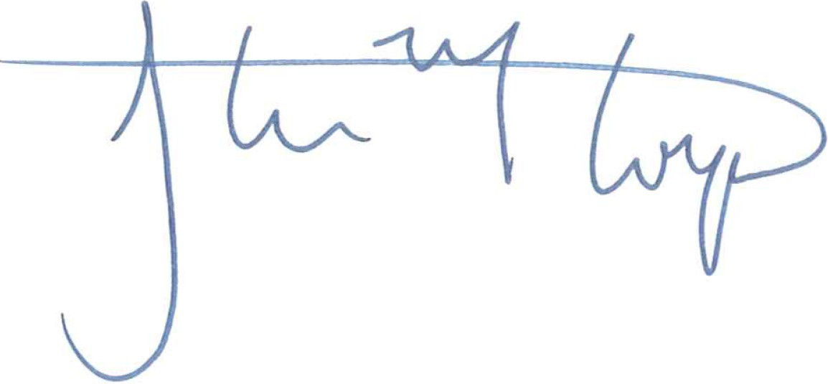

By:

Name: Steven Coyne Its: President

Date: March 24, 2021

# “Seller” Pegasus Development

By:

Name: Michael Cleavenger

Its: President

Date: **______________________________**